PERSONAL PROJECT – SQL-DDL AND DQL
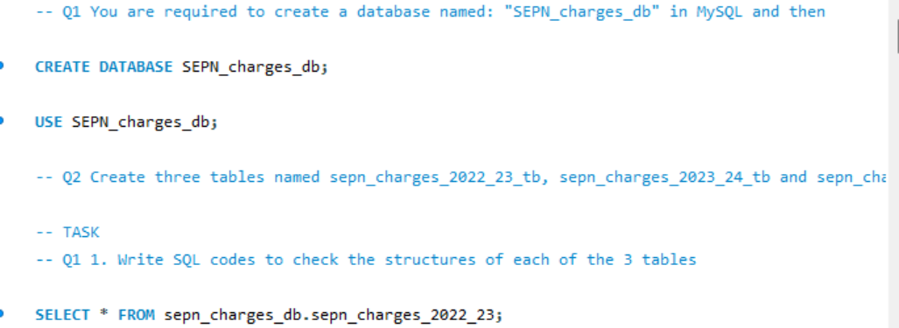

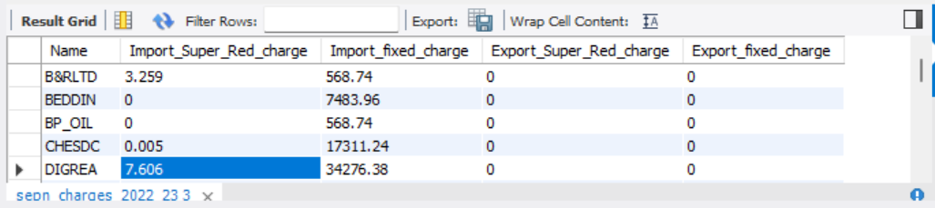

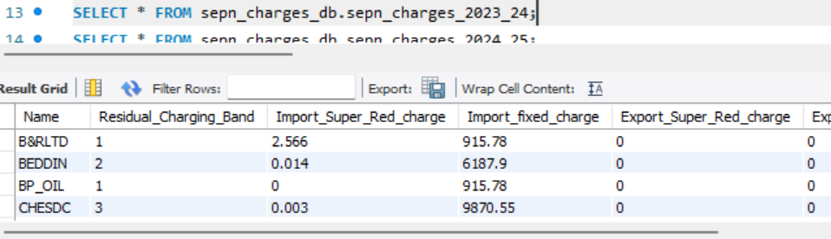

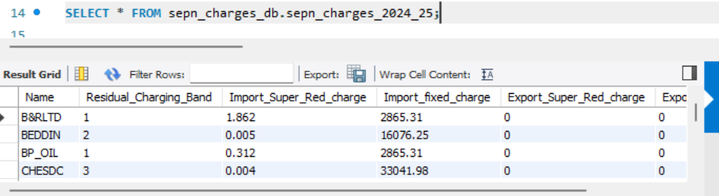

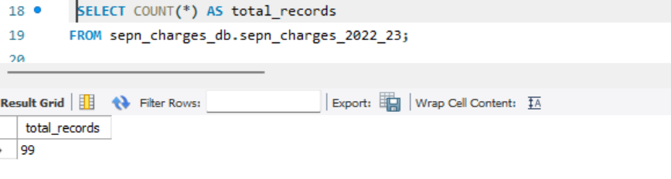

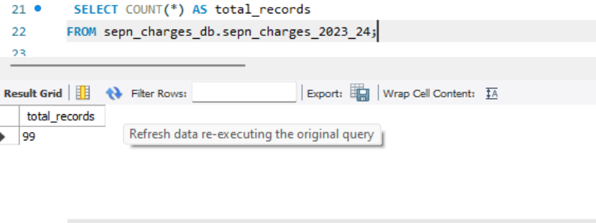
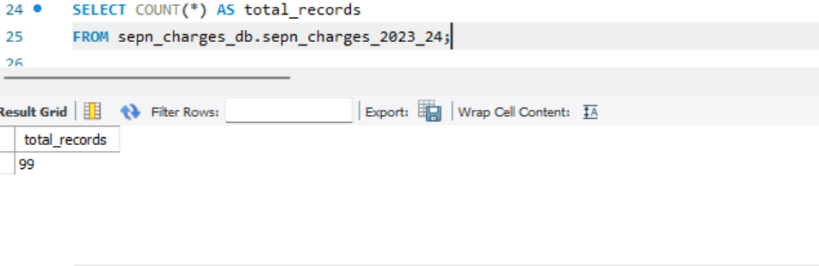

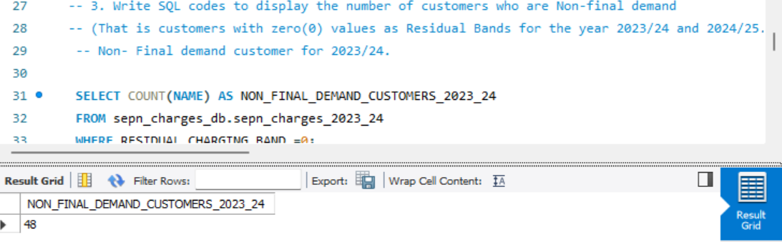

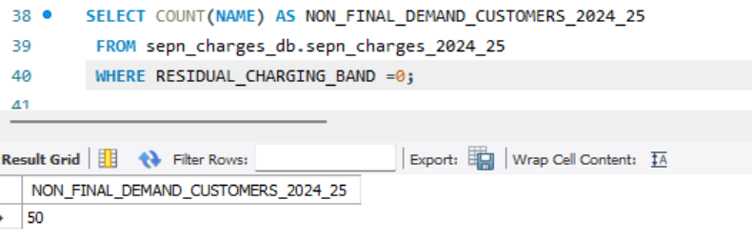

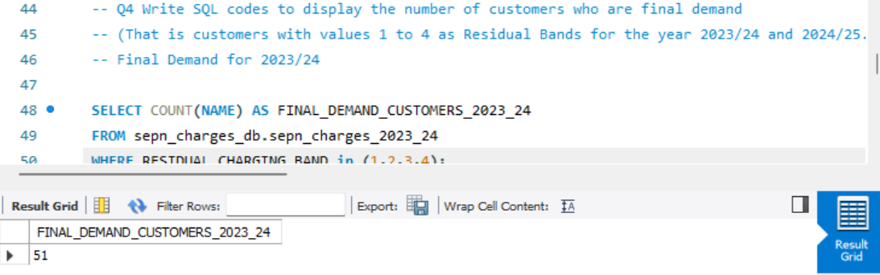

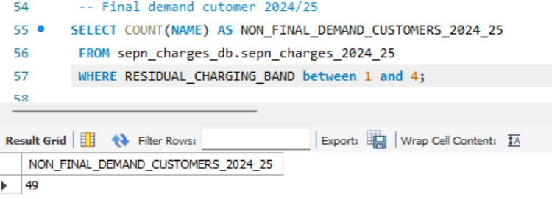

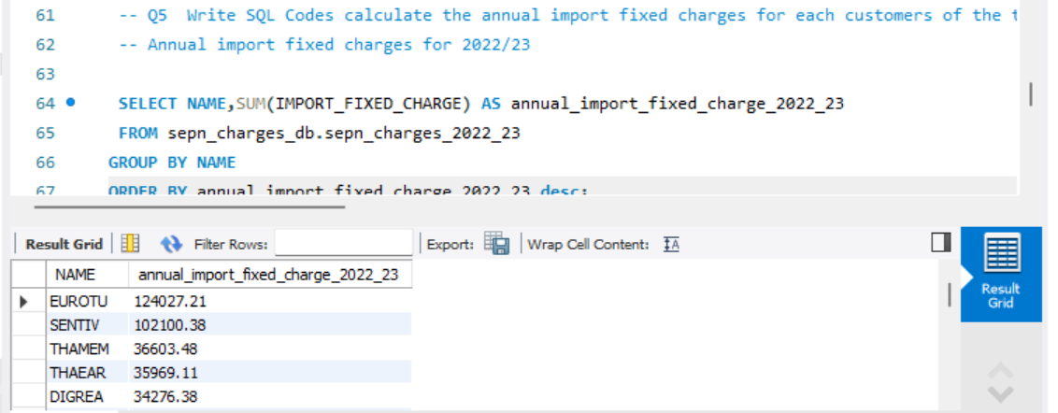

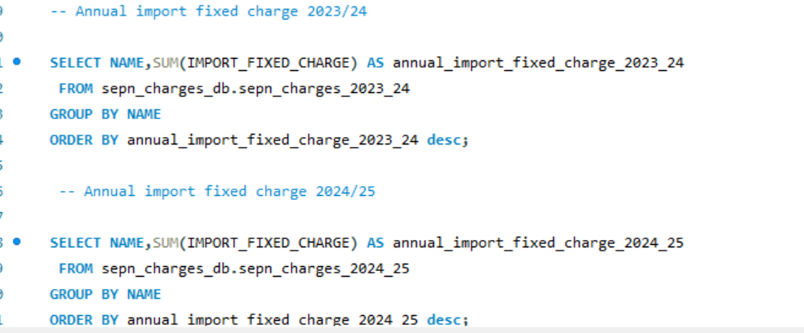

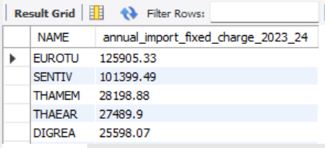

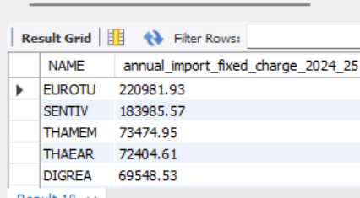

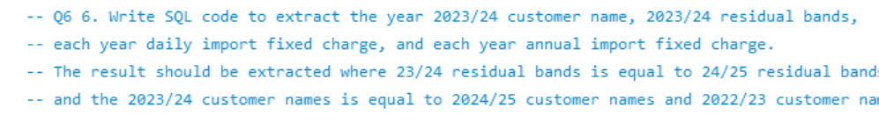

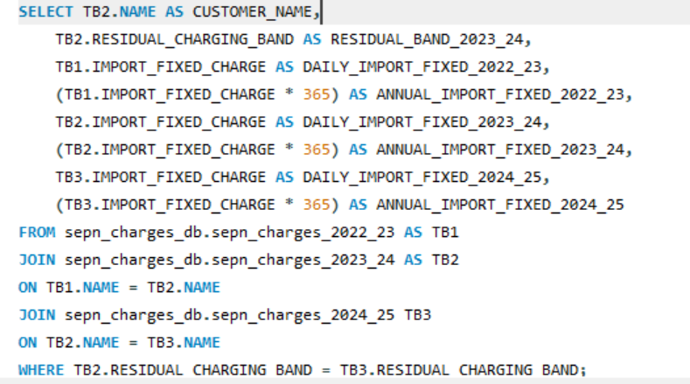

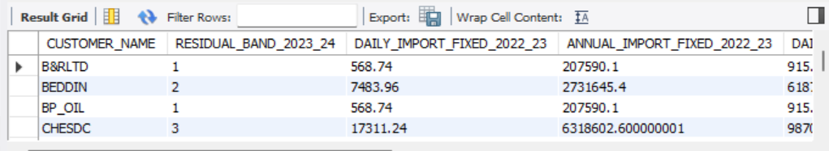

-- Q7. Create a temporary table (view) based on the query results in question 6.
CREATE VIEW Customer_import_fixed_charge_2022_23_24_25 AS
SELECT TB2.NAME AS CUSTOMER_NAME,
TB2.RESIDUAL_CHARGING_BAND AS RESIDUAL_BAND_2023_24,
TB1.IMPORT_FIXED_CHARGE AS DAILY_IMPORT_FIXED_2022_23,
(TB1.IMPORT_FIXED_CHARGE * 365) AS ANNUAL_IMPORT_FIXED_2022_23,
TB2.IMPORT_FIXED_CHARGE AS DAILY_IMPORT_FIXED_2023_24,
(TB2.IMPORT_FIXED_CHARGE * 365) AS ANNUAL_IMPORT_FIXED_2023_24,
TB3.IMPORT_FIXED_CHARGE AS DAILY_IMPORT_FIXED_2024_25,
(TB3.IMPORT_FIXED_CHARGE * 365) AS ANNUAL_IMPORT_FIXED_2024_25
FROM sepn_charges_db.sepn_charges_2022_23 AS TB1
JOIN sepn_charges_db.sepn_charges_2023_24 AS TB2
ON TB1.NAME = TB2.NAME
JOIN sepn_charges_db.sepn_charges_2024_25 TB3
ON TB2.NAME = TB3.NAME
WHERE TB2.RESIDUAL_CHARGING_BAND = TB3.RESIDUAL_CHARGING_BAND;

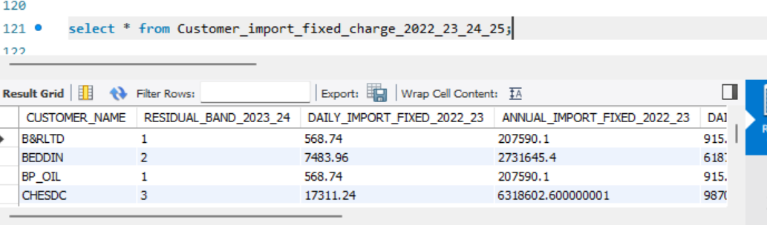

-- Q8 Write a SQL query to extract the residual bands and annual fixed charges
-- from the view created in question 7 and then Aggregate the annual fixed charges
-- based on bands for each year and order them based on bands.

SELECT CUSTOMER_NAME,RESIDUAL_BAND_2023_24,
SUM(ANNUAL_IMPORT_FIXED_2022_23) AS TOTAL_ANNUAL_FIXED_2022_23,
SUM(ANNUAL_IMPORT_FIXED_2023_24) AS TOTAL_ANNUAL_FIXED_2023_24,
SUM(ANNUAL_IMPORT_FIXED_2024_25) AS TOTAL_ANNUAL_FIXED_2024_25
FROM Customer_import_fixed_charge_2022_23_24_25
GROUP BY 1,2
ORDER BY RESIDUAL_BAND_2023_24 DESC;

